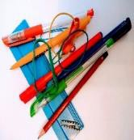

Maths Functional Skills Initial Assessment

Learner`s Name

Date of Assessment

Score

Level

Working Towards

Do Not Use a Calculator

 | Work out the answers to the following questions. | Answers
1 | Put these numbers in the correct order.  13 7 19 14 3 8 12
2 | 9  +8
3 | 39  +47
4 | A cafe served 213 lunches on Monday, 281 on Tuesday, 145 on Wednesday, 129 on Thursday and 199 on Friday. How many lunches were served in total?
5 | 7 – 4 =
6 | Sam is 31, Jordan is 9 years younger. How old is Jordan?
7 | 31  x 65
8 | 36 ÷ 4 =
9 | 2525 ÷ 25 =
10 | Put these fractions in order of size starting with the smallest  3 3 2 2  4 8 6 3
11 | 7 + 99.9 + 0.06 =

12 | In a sale normal prices are reduced by 7%.  The sale price of a tumble dryer is £210 What was the price before the sale?
13 | Copper and zinc are mixed in an alloy in the ratio  7 3  copper to zinc  10 10  How much copper is there in 450g of the alloy?
14 | 81 – ( 4² + 7 x 8 ) =
15 | What time does the clock show?  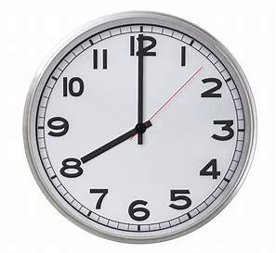
16 | Mark the following temperatures on the thermometer.  - 32⁰F  - 60⁰F  - 22⁰C  - 58⁰C
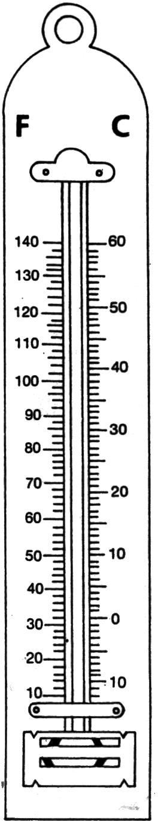

17 | Fish and Chip Shop Prices  Cod -small £4.10  Cod -medium £4.80  Cod -large… £5.75  Plaice £4.80  Fishcake £1.70  Chicken portion £4.40  Meat pie £2.70  Veggie Burger £3.50  Pancake roll £1.90  Chips – small £2.20  Chips – large £5.10  Curry sauce tub £1.30  What does a medium cod, a large portion of chips and a curry sauce tub cost in total?
18 | Change 2456 cm to metres (m)
19 | Calculate the volume of this shape. State the units.  16mm  20mm  24mm
20 | What is the area of this shape to two decimal places? State the units.  4.4cm
12mm

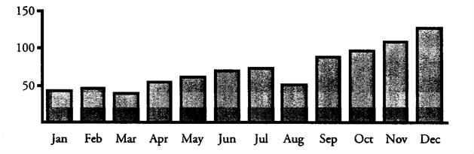
21
Complete the chart below

Production  Line | Boxes Produced |  |  | Total
1 | IIII  IIII | IIII  II | IIII
2 | IIII | IIII | IIII

22
Factory | Football League
Browns Unit | 0 - 0 | Green Company
Bara Bakery Unit | 1 - 2 | Berry Products
SMT | 0 - 1 | Yellow Inc
Horittts Ltd | 2 - 1 | Ganners
Glook Plans | 1 - 0 | KTP
Barnes Barns | 1 - 1 | Malcolm Ovens
Red Unit | 2 - 0 | Guppas
Lobble Inc | 3 - 0 | HYV Purple
Lavis Brothers | 0 - 1 | Silop Products
ZPQ and Partners | 1 - 0 | Jissops

How many teams scored 2 goals?

23 Number of Reported Injuries to Children in the Home
Ten thousands

What is the trend of reported injuries to children in the home throughout the year?

24
There are 24 sweets in a bag. Four sweets are mint toffees.
Two sweets are humbugs. Three sweets are lemon jellies. One sweet is picked at random. What is the probability of picking a lemon jelly? Give your answer as a fraction.

25 Below are the weekly takings for six shops in a High Street.

£43 995 | £68 750 | £109 500
£125 000 | £17 000 | £368 995.
Calculate the median for this set of data?

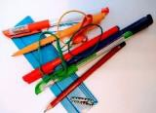
Production  Line | Boxes Produced |  |  |  | Total
1 | IIII | IIII IIII | IIII | II | 22
2 | IIII | IIII IIII |  |  | 15

Student Name
 | Work out the answers to the following questions. | Mark
1 | Put these numbers in the correct order. 3 7 8 12 13 14 19
2 | 9  +8  17
3 | 39  +47  86
4 | A cafe served 213 lunches on Monday, 281 on Tuesday, 145 on Wednesday, 129 on Thursday and 199 on Friday. How many lunches were served in total? 967
5 | 7 – 4 =3
6 | Sam is 31, Jordan is 9 years younger. How old is Jordan? 22
7 | 31  x 65  2015
8 | 36 ÷ 4 = 9
9 | 2525 ÷ 25 =101
10 | Put these fractions in order of size starting with the smallest.  2 3 2 3  6 8 3 4
11 | 7 + 99.9 + 0.06 = 106.96
12 | In a sale normal prices are reduced by 7%.  The sale price of a tumble dryer is £208.32 What was the price before the sale? £224.00
13 | Copper and zinc are mixed in an alloy in the ratio ⁷ copper to ³ zinc  10 10  How much copper is there in 450g of the alloy? 315g
14 | 81 – ( 4² + 7 x 8 ) = 9
15 | What time does the clock show? 08:00 or8am
16 | Mark the following temperatures on the thermometer.
17 | What does a medium cod, a large portion of chips and a curry sauce tub cost in total? £11.20
18 | Change 2456 cm to metres (m) 24.56m
19 | Calculate the volume of this shape. State the units. 7680mm³or7.68 cm³
20 | What is the area of this shape to two decimal places? State the units. 60.79cm²
21 | Complete the chart below
22 | How many teams scored 2 goals? 3
23 | Number of Reported Injuries to Children in the Home  What is the trend of reported injuries to children in the home throughout the year? Injuries to children increased gradually throughout the year but lowered in August.  (answer must include gradual increase and dip in August for mark
24 | There are 24 sweets in a bag. Four sweets are mint toffees. Two sweets are humbugs. Three sweets are  lemon jellies. One sweet is picked at random. What is the probability of picking a lemon jelly? Give your answer as a fraction. 1/8
25 | Below are the weekly takings for six shops in a High Street.£43 995 £68 750 £109 500 £125 000  £17 000 £368 995.Calculate the median for this set of data? £89,125
 | TOTAL
 | LEVEL

Score | Level
0-5 | Entry 1
6-10 | Entry 2
11-15 | Entry 3
16-20 | Level 1
20-25 | Level 2

