Name Date Mentor
Delivery Partner Participant ID
Is this the 1st 2nd 3rd
4th 5th+
time you are completing a Progress Star?

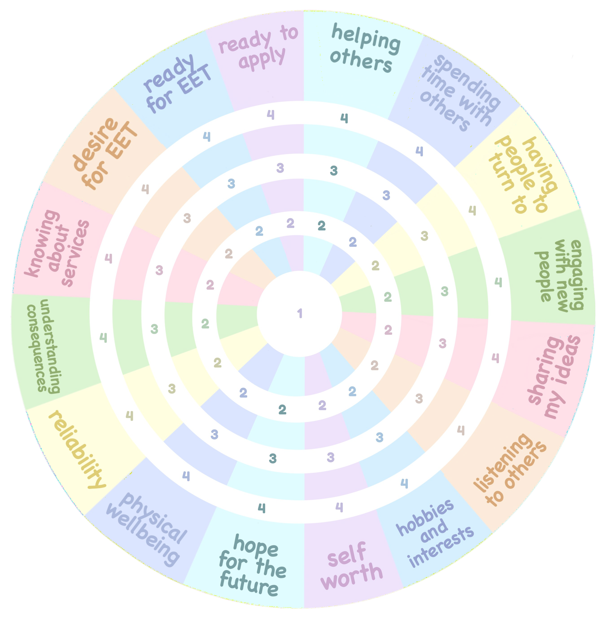

Create a Progress Star

