

PARENT PORTAL
USER GUIDE

This guide is designed to help you through the steps of logging in and viewing the Parent Portal.

If you are a named contact for a student at North Devon College and you have supplied an email address, you will have received an email from us stating that an account has been setup for you linked to the student. This email will contain your username and password if you don't already have a myPetroc account. If you haven’t supplied an email address, please contact the Faculty Administration Team who will be able to add your email address so a linked account can be created. If you are not a contact for the student but think you should be, please note that we can only add you at the request of the student.

VISIT OUR WEBSITE
Go to www.petroc.ac.uk – click on the myPetroc link in the top right-hand corner.

LOG IN TO MYPETROC

Enter your username and password and click ‘Login to myPetroc’.

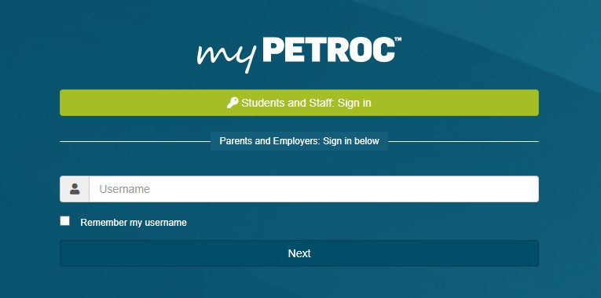
If you already have a myPetroc account and you have forgotten your password, you can click on the ‘Reset password’ link in the myPetroc login pane (shown in the bottom right of the screenshot below).
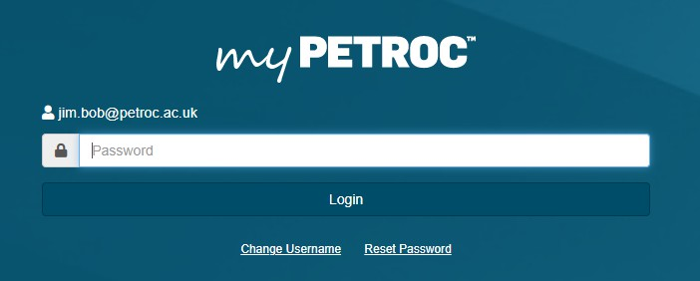

MYPETROC DASHBOARD

Once you have logged in, you should see the Parent Portal dashboard pane which will list the names of all students linked to your account. You can click on their name to take you to their record.

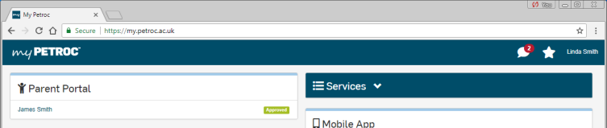

COMPLETE!

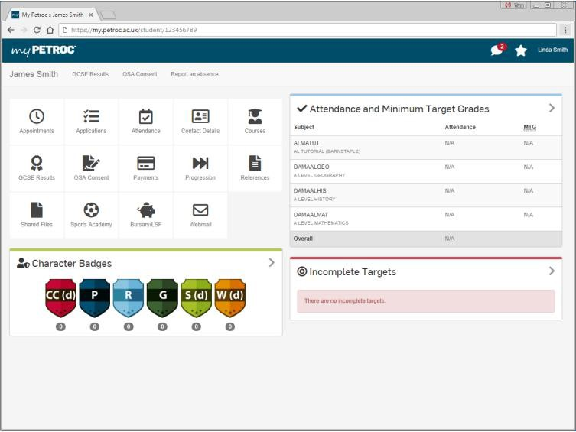
You’re now viewing the Parent Portal. Below is the main ‘dashboard’ where you can select information such as attendance, appointments and payments.

