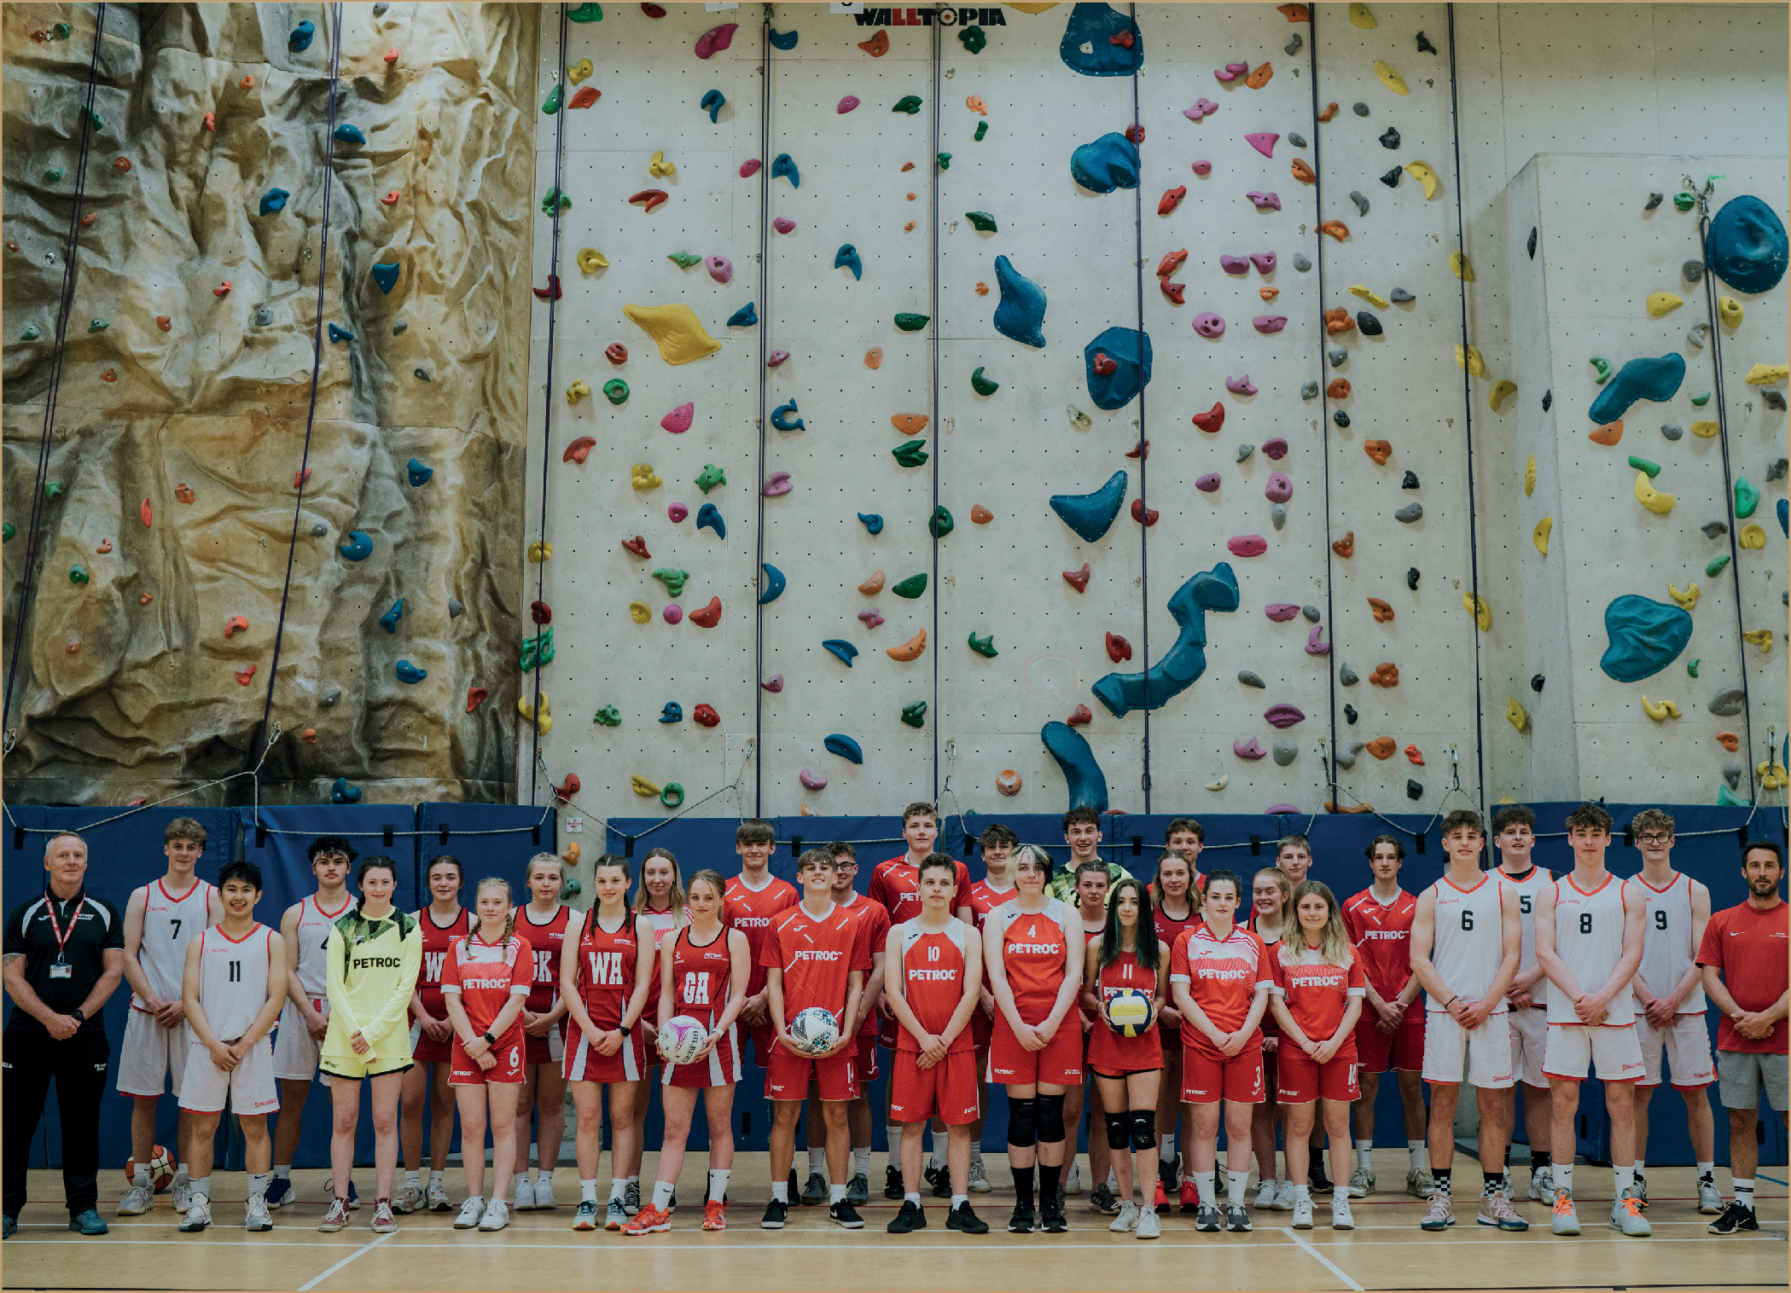
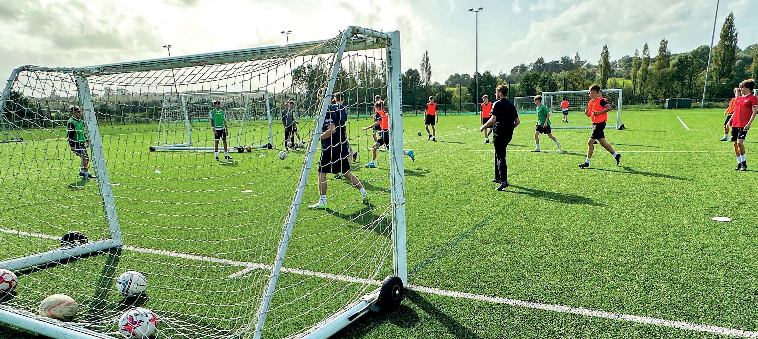
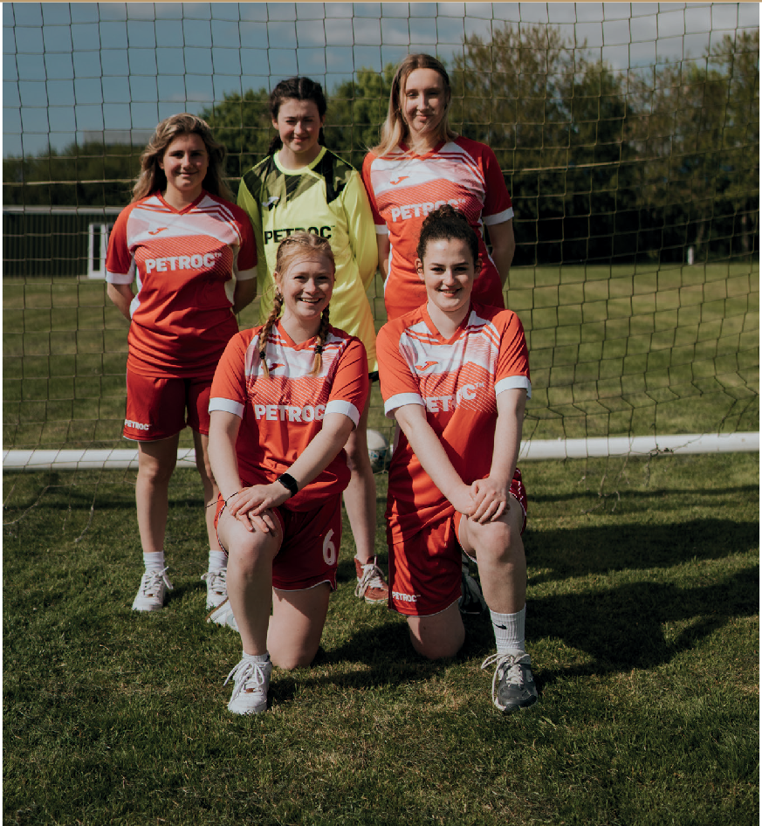
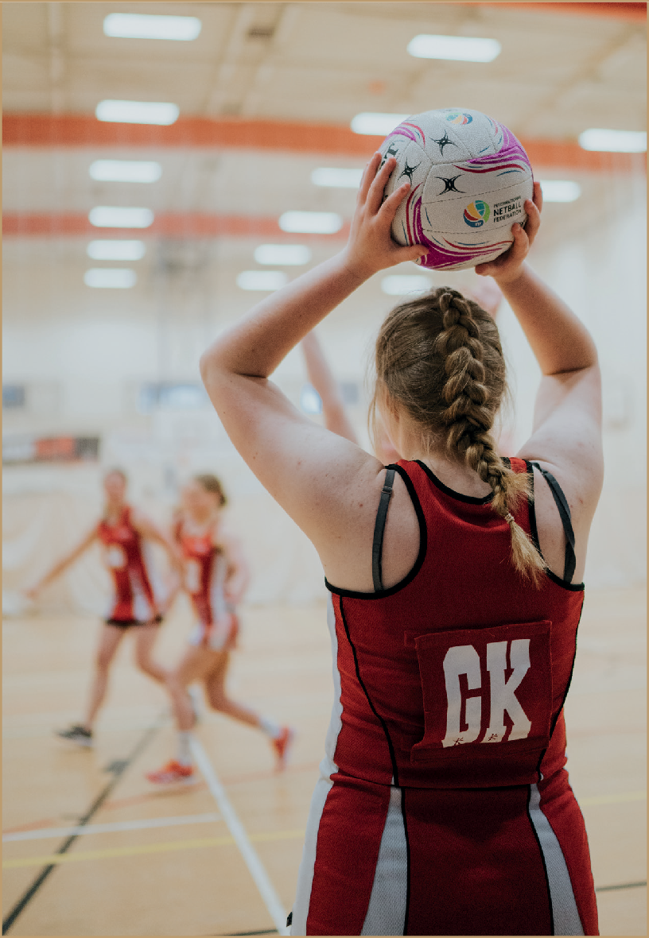
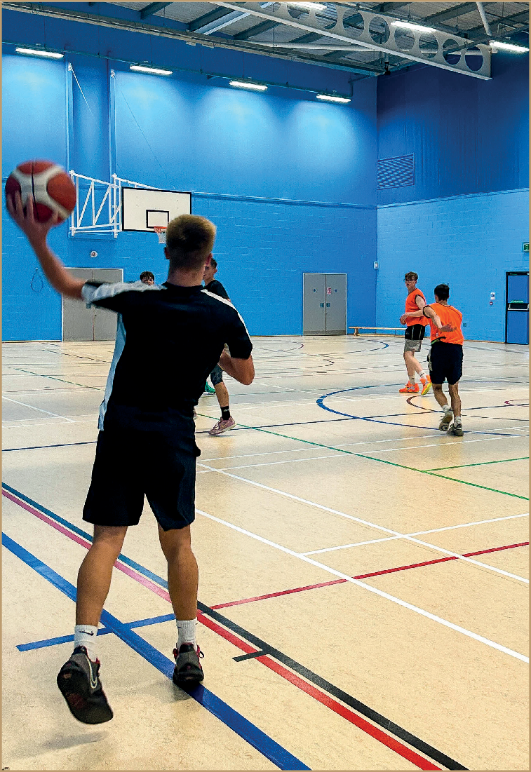
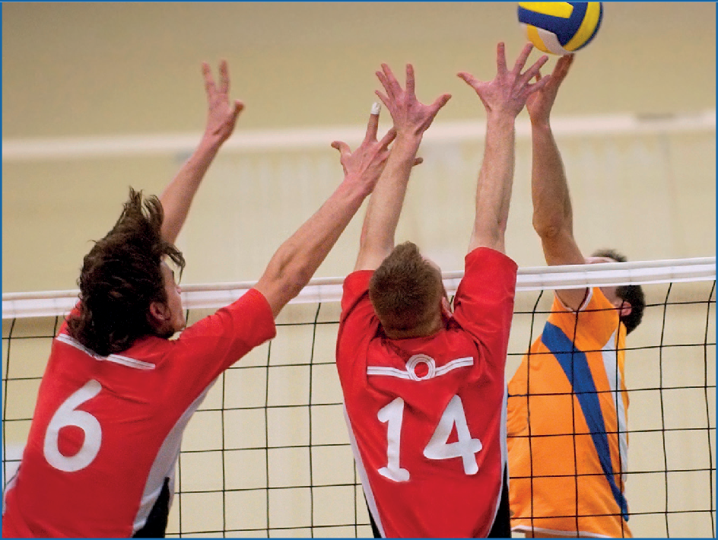
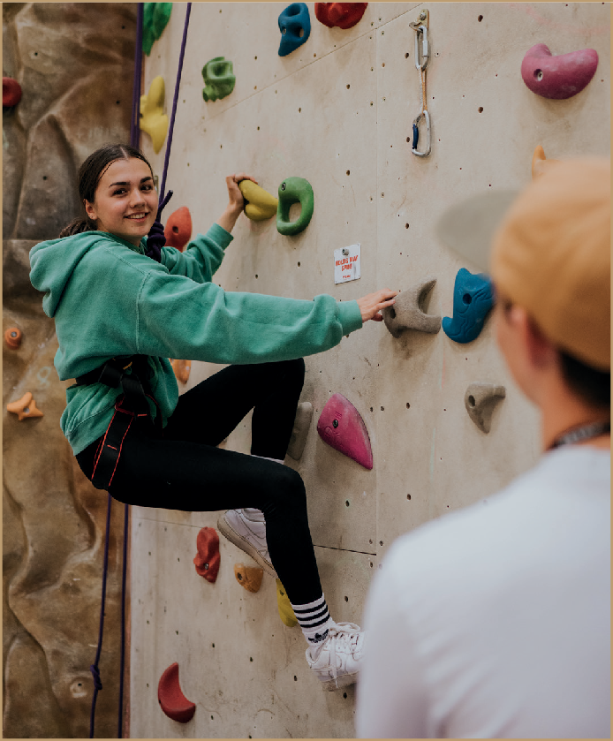



petroc.ac.uk

WHAT CAN YOU EXPECT FROM SPORT AT NORTH DEVON COLLEGE?

Do you want to be part of the multi-billion pound health and fitness industry? Do you want to develop your own brand, find a social media audience focussed on health, create a bespoke training service or open your own fitness centre?
OUR SPORTS COURSES
LEVEL 1 | SPORT
This introductory programme combines classroom theory and practical learning to provide you with a taste of three exciting subjects: Public Services, Animal Care and Sport. You will learn from curriculum experts about the skills needed in the work environment as well as discover opportunities for further study at North Devon College.
LEVEL 3 | SPORT BTEC (A LEVEL EQUIVALENT)
This course is designed for students who wish to study a sport and physical education topic alongside other A Level subjects. You will cover anatomy and physiology in sport, practical sports performance, fitness training and programming and professional development in the sports industry.
LEVEL 3 | SPORT AND OUTDOOR ACTIVITIES
This National Extended Diploma in Sport and Outdoor Activities blends classroom-based theory with practical activities. You’ll get to experience outdoor rock climbing, kayaking, canoeing, mountain biking, navigating, coasteering, gorge walking and anything else we can cram in! You must be happy to get cold, wet and muddy, and accept and manage the risks involved in what are potentially dangerous activities.
LEVEL 3 | SPORT
This National Extended Diploma in Sport covers many aspects of the sports industry and gives an excellent academic sport background to take forward into a related career. The qualification combines theoretical research assignments with practical assessment and includes a wide range of areas related to sport and fitness. You’ll also take an active role in various sports events in the local community.
LEVEL 2 | SPORT
This Certificate in Sport is designed for anyone with a passion for sport. It will give you a taste of the skills and experiences you’ll need to succeed in a career in sport! You will be involved in planning and leading sports activities, instructing exercise to others and contributing to real-life sport experiences. You will also have the opportunity to gain real leadership skills in a range of settings such as schools, sports and physical activity festivals and community events.
If you are highly motivated to develop yourself physically and mentally, one of our sports programmes could be the perfect option for your next career step. You will learn alongside like-minded individuals, looking to explore career options that optimise holistic health and fitness and make your mark in this rapidly growing sector.
With a wealth of opportunities including fitness and nutrition coaching, wearable health tech, and gym wear and equipment, this is an industry for innovative and driven individuals.
By studying a sports programme at North Devon College, you will gain essential practical experience to support the theoretical elements of the course and have valuable opportunities to work within the local community in settings such as schools, festivals and community events. By exploring the many facets of this industry, you will be able to identify business and employment opportunities to suit your aspirations, whether you decide to step straight into employment, start your own business or move onto a related degree.

We’re proud of our North Devon College alumni who have found success as PE teachers, personal trainers, nutritionists and sports massage therapists and many more have secured highly sought-after places at some of the country’s leading sports universities.

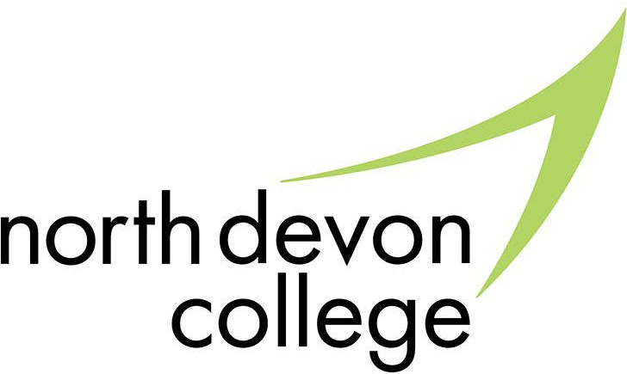
1 Statista
FACILITIES
Petroc’s sports courses have the exclusive benefit of being delivered from the brand-new Tarka Leisure Centre in Barnstaple.
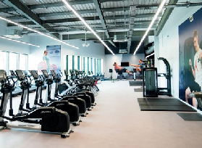
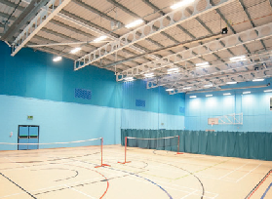
The Tarka Leisure Centre features an impressive range of facilities including a multi-use sports hall, a 110+ station gym and 2 fitness studios. There’s also a dedicated teaching space as well as a special area where students can relax or study.
Joining a North Devon College Sports Academy will keep you active, allow you to hone your talents and learn about nutrition, sports psychology, health and wellness.
We offer a fantastic suite of academies that will motivate, inspire and help you develop your skills on and off the pitch.
- Basketball
- Chelsea FC Foundation (CFCF) Academy
- Climbing
- Men’s Football
- Netball
- Rugby
- Surfing
- Volleyball
- Women’s Football

North Devon College players and athletes have represented the South West, England and Great Britain in their chosen sports in both league and cup fixtures and have enjoyed some fantastic successes!
discover
more!

YOUR LECTURERS
With a wealth of knowledge, experience and passion, our sports lecturers will inspire you, help you develop your playing and leadership skills, and support your career aspirations.

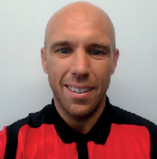
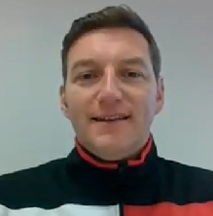
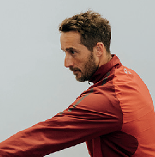
Alex Bird: Alex has a love for all sports, fitness, and outdoor activities. His passion for all things active is infectious, making him a motivating and inspiring lecturer for aspiring sports enthusiasts.


Ben Lugsden: Ben has been working with young athletes for over 20 years and specialises in anatomy and physiology, skill acquisition and sports psychology. He enjoys all sports and
is keen to pass on all he can to the next generation of sports leaders.

Andy Rose with the Men’s Football Team after winning the AoC Sport Regional League South.
Charlie Smith: Charlie is passionate and enthusiastic about sports performance, skill acquisition and fitness training and loves using practical-based learning to aid students’ knowledge and understanding.






"I initially chose to study at North Devon College because I saw the amazing facilities, it is in a very accessible location and North Devon College sports staff are all amazing! Every single one of them has a reputation with ex-students and I can see why. The lecturers are friendly, patient and make sure every student gets the help and support they need to reach the best grade possible."
HARVEY, SPORT (FORMER STUDENT OF PILTON COMMUNITY COLLEGE)
There were estimated to be approximately 110,500
sports coaches working in the UK as of 20221
discover
more!
SCHOLARSHIPS
In addition to our academies, we offer scholarships in all non-academy sports to support individuals. If you are an aspiring sports professional, we can support you in a number of ways. Just email sportsscholarships@petroc.ac.uk to find out more.

