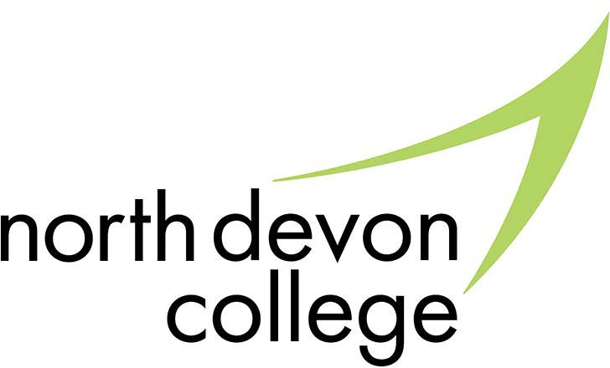
Subject Access Request Policy and Procedure
Contents:
- Introduction
- Purpose of the Procedure
- General Principles/Procedures
  - Rights of access by data subjects
  - How to make a subject access request
  - Responding to requests
  - Fees associated with requests
  - Refusing a request
- Monitoring and Review
- Useful Links
Appendix 1: Subject Access Request Procedure

- Introduction

Policy Name: Subject Access Request Policy/Procedure | Policy No: 149001
Approved Date: June 2023 | Review Date: June 2026
Approved by: College Leadership Team | EqIA Completed: Yes
Author: Data Protection Ofﬁcer | Monitoring & Evaluation: College Leadership Team

  - As data controllers, organisations such as North Devon College, are bound by the rights of data subjects when processing data. The rights of data subjects, whether learners or employees, include the right of access to personal data concerning them.
  - North Devon College has an obligation to comply with the UK General Data Protection Regulation¹ (UK GDPR), and the Data Protection Act 2018² (DPA 2018) which supplements the requirements of the UK GDPR.
  - Outlined in Article 15³ of the UK GDPR, individuals have the right to submit a request to organisations to access information that is held about them. These are referred to as Subject Access Requests (SARs or DSARs).
- Purpose of the Policy
  - The SAR Policy and Procedure explains an individual's rights to make a Subject Access Request under the UK GDPR and sets out the processes that the College has in place to deal with these requests effectively.
  - The aims of the policy are to:
- Enable the college to demonstrate that it complies with the Data Protection Act 2018;
- Ensure that all staff and members of North Devon College are briefed on the Subject Access Request Procedure;
- Deﬁne individual’s rights with regard to accessing information held about them;
- Ensure that key timelines are met in accordance with these; and
- Give direction and guidance for dealing with requests
  - This procedure also aims to deﬁne any boundaries and parameters that North Devon College must adhere to with regards to data that can be provided to data subjects.
- General Principles/Procedures
  - Rights of access by data subjects
    - In accordance with UK GDPR and the DPA 2018, individuals have the right to obtain
from the controller (North Devon College) conﬁrmation as to whether or not personal data concerning them are being processed, and, where that is the case, access to the
personal data and the following information provided that it does not breach the rights of others::
      - the purposes and legal basis of the processing;
      - the categories of personal data concerned;
      - the recipients or categories of recipient to whom the personal data have been or will be disclosed;
      - where possible, the envisaged period for which the personal data will be stored, or, if not possible, the criteria used to determine that period;
      - the existence of the right to request from the controller rectiﬁcation or erasure of personal data or restriction of processing of personal data concerning the data subject or to object to such processing;

¹ https://uk-gdpr.org/
² https://www.legislation.gov.uk/ukpga/2018/12/contents/enacted
³ https://uk-gdpr.org/chapter-3-article-15/

Policy Name: Subject Access Request Policy/Procedure | Policy No: 149001
Approved Date: June 2023 | Review Date: June 2026
Approved by: College Leadership Team | EqIA Completed: Yes
Author: Data Protection Ofﬁcer | Monitoring & Evaluation: College Leadership Team

      - the right to lodge a complaint with the Commissioner;
      - where the personal data are not collected from the data subject, any available information as to their source;
      - the existence of automated decision-making, including proﬁling, referred to in Article 22(1) and (4) and, at least in those cases, meaningful information about the logic involved, as well as the signiﬁcance and the envisaged consequences of such processing for the data subject.
        - Where personal data are transferred to a third country or to an international organisation, the data subject shall have the right to be informed of the appropriate safeguards pursuant to Article 46 relating to the transfer.
        - The controller shall provide a copy of the personal data undergoing processing. For any further copies requested by the data subject, the controller may charge a reasonable fee based on administrative costs. Where the data subject makes the request by electronic means, and unless otherwise requested by the data subject, the information shall be provided in a commonly used electronic form.
        - The right to obtain a copy referred to in section 2 shall not adversely affect the rights and freedoms of others.
  - How to make a Subject Access Request
    - Any subject access requests submitted to North Devon College should be requested by the individual, with the requestor providing proof of identiﬁcation.
    - Subject access requests should be made in writing to: dpo@petroc.ac.uk and provide the following:
- Full name
- Date of birth
- Academic department or corporate division
- Learner or staff number (if known/applicable)
- Information that the requestor would like to access
- Location that the information is likely to be held (if known)
- Contact details, I.E: Email address, phone number, address.
- The format that the data subject would like the information provided in, I.E: Email, Zip File
    - Should an individual make a subject access request in person or via the phone, they will be asked to submit a request in writing, using the guidelines above. This helps to verify the requestor's identity and evidence the time that the request was made, as well as keeping accurate records. As per ICO guidance, SAR requests can also be made verbally, and a verbal response is able to be provided to the requestor, should their identity be conﬁrmed by other means. This correspondence will still need to be logged.
    - Although section 3.2.2 provides guidelines to submitting subject access requests, there is no prescribed format for a valid subject access request under the UK GDPR. Data subjects do not have to use speciﬁc language, refer to the UK GDPR, or state that they are making a subject access request. However, a request is only valid if it is made clear that an individual is asking for their own personal data.
    - If the data subject is a learner under the age of 18, North Devon College will to the best of its ability, consider whether the learner is mature enough to understand their rights. If the college is conﬁdent that they can understand their rights, response will normally be

Policy Name: Subject Access Request Policy/Procedure | Policy No: 149001
Approved Date: June 2023 | Review Date: June 2026
Approved by: College Leadership Team | EqIA Completed: Yes
Author: Data Protection Ofﬁcer | Monitoring & Evaluation: College Leadership Team

directly to the learner. However, in instances where the college is not conﬁdent, North Devon College might allow the parent or guardian to exercise the learner’s right on their behalf, if they authorise this, or if it is evident that it is in the best interests of the learner. Conﬁrmation of identiﬁcation/ relationship to the learner will be needed in these circumstances. A learner may also be able to authorise someone else, other than a parent/guardian, to make a subject access request on their behalf.
  - Responding to requests
As the controller of the information, North Devon College is responsible for taking all reasonable steps to ensure security of the information provided in response to
a subject access request. The college will also aim to provide information in accordance with the data subject’s preferred format of receiving the information. For instance, where the data subject makes a request by electronic means, North Devon College will provide response by electronic means, unless otherwise requested.
    - Timeframes
In accordance with Article 15 of UK GDPR, North Devon College has a duty to provide information in response to a subject access request to the data subject (requestor) without delay and within one month of receipt of the request.

The timescale for responding to a subject access request may not begin untiNorth Devon College has received means to identify a data subject.
This period of response may be extended to two further months where necessary, taking into account the complexity and number of requests. In this instance, North Devon College must inform the data subject of any such extension within one month of receipt of request, alongside reasons for the delay.
Should North Devon College not provide response to the request, the data subject must be informed without delay, at the latest within one month of receipt of the request, providing reasoning for not taking action, and advise the data subject of the possibility of lodging a complaint with a supervisory authority, the Commissioner, and seeking a judicial remedy.
    - Categories of data
As stated in 3.2.2, subject access requests should provide a description of the information that the requestor is seeking to receive. This guidance will enable the college to efﬁciently ﬁnd and respond to a subject access request.
Data subjects are able to request categories such as:
- Learners: ﬁles, marks, counselling records, disability records
- Staff: HR records, employment ﬁles, personal development discussions, safety records.
North Devon College will make reasonable efforts to ﬁnd and retrieve the requested information. However, the college is not required to conduct searches that would be unreasonable or disproportionate to the importance of providing access to the information.
    - Redactions

Policy Name: Subject Access Request Policy/Procedure | Policy No: 149001
Approved Date: June 2023 | Review Date: June 2026
Approved by: College Leadership Team | EqIA Completed: Yes
Author: Data Protection Ofﬁcer | Monitoring & Evaluation: College Leadership Team

North Devon College will carefully consider whether it is possible to comply with the request without disclosing information that identiﬁes another individual. If this is not possible in any circumstances, North Devon College may not be obligated to comply with the request, unless the other individual consents to the disclosure, or it is reasonable to comply with the request without the other individual’s request.
In some instances, North Devon College will redact information that identiﬁes other individuals to the best of its ability, by either omission or obscuring text.
It is Petroc’s obligation to respond to the requestor whether or not a disclosure is permitted, with justiﬁcation for the decision to disclose or withhold information about a third party.
  - Fees associated with requests
    - Information provided in response to a subject access request will normally be provided free of charge.
    - However, in rare cases where requests are manifestly unfounded or excessive, particularly in instances where repeat requests are received, North Devon College might:
- charge a reasonable fee taking into account the administrative costs of providing the information or communication or taking the action requested; or
- refuse to act on the request.
In the above cases, it is Petroc’s responsibility to demonstrate the manifestly unfounded or excessive character of the request, and to respond to the requestor.
  - Refusing a request
Exemptions to refusing a request are outlined in the UK GDPR and DPA 2018, to which North Devon College must comply. In most cases, subject access requests that are manifestly unfounded or excessive, will be refused, with rationale for doing so provided by the college. If cases are believed to be manifestly unfounded or excessive, North Devon College will demonstrate this to the individual in its response.
However, the college seeks to review each subject access request individually, and will aim to apply context, if known, to every request received.
A full list of instances where exemptions may apply to a subject access request can be found in Section 45 of the DPA 2018⁴.
In any instance where an exemption may occur and North Devon College refuses a subject access request, the college is obligated to inform the data subject of:
- Reasons for request refusal;
- Their right to make a complaint to the ICO; and
- Their ability to seek to enforce this right through the courts
- Monitoring and Review

⁴ https://www.legislation.gov.uk/ukpga/2018/12/section/45/enacted

Policy Name: Subject Access Request Policy/Procedure | Policy No: 149001
Approved Date: June 2023 | Review Date: June 2026
Approved by: College Leadership Team | EqIA Completed: Yes
Author: Data Protection Ofﬁcer | Monitoring & Evaluation: College Leadership Team

  - Data pertaining to Subject Access Requests is recorded in a tracker throughout each academic year.
  - Overall reports on SARs are presented to the College Leadership Team and the Governing Board on an annual basis.
  - This Policy and Procedure will be monitored and reviewed every three years by Petroc’s Data Protection Ofﬁcer, with approval from the College Leadership Team. The policy may be reviewed before the end of this duration should there be changes in legislation.
- Useful links
More information on subject access requests can be found at:
- Data Protection Act 2018: https://www.legislation.gov.uk/ukpga/2018/12/contents/enacted
- UK GDPR: https://uk-gdpr.org/
- Information Commissioner’s Ofﬁce:
https://ico.org.uk/for-organisations/guide-to-data-protection/guide-to-the-gen eral-data-protection-regulation-gdpr/individual-rights/right-of-access/

Policy Name: Subject Access Request Policy/Procedure | Policy No: 149001
Approved Date: June 2023 | Review Date: June 2026
Approved by: College Leadership Team | EqIA Completed: Yes
Author: Data Protection Ofﬁcer | Monitoring & Evaluation: College Leadership Team

Appendix 1: Subject Access Request Procedure
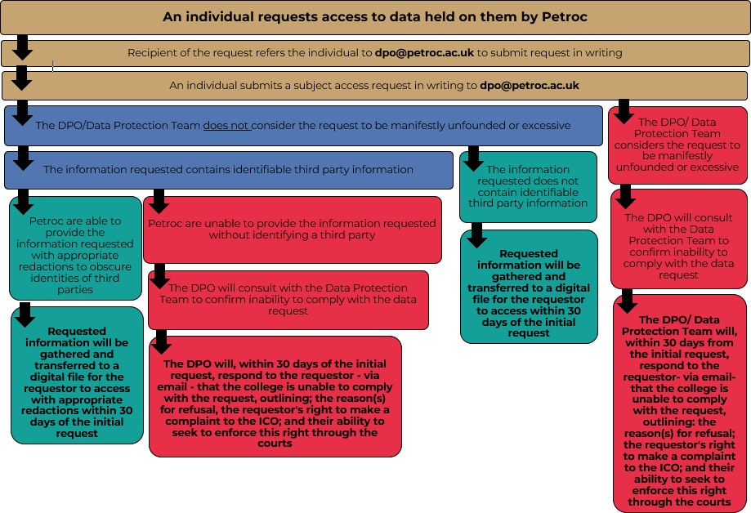

Policy Name: Subject Access Request Policy/Procedure | Policy No: 149001
Approved Date: June 2023 | Review Date: June 2026
Approved by: College Leadership Team | EqIA Completed: Yes
Author: Data Protection Ofﬁcer | Monitoring & Evaluation: College Leadership Team

