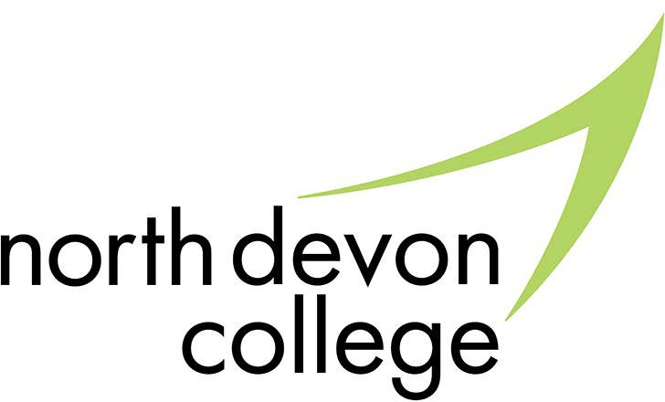

North Devon College Sustainability Policy

- Introduction
Petroc is dedicated to fostering an environment where sustainability is integral to all aspects of education, operations, and community life.
Through this policy, North Devon College will support the development of a sustainable future, empowering students and staff to act as responsible global citizens. North Devon College is committed to advancing sustainability across all areas of its operations, in alignment with the UN Sustainable Development Goals
(SDGs). The college recognises its responsibility to support a healthy environment, respect biodiversity, and contribute positively to our community. All staff, students, and partners are expected to adhere to these sustainability principles and actively participate in creating a sustainable future.

Purpose of the Policy
The purpose of this policy is to embed sustainability in all facets of college life, from education to operations, guiding staff and students to make a positive environmental impact. North Devon College aims to foster environmental awareness, conserve resources, and empower students with skills that promote sustainable practices within and beyond the college.

The Three Pillars of Sustainability
Petroc College’s sustainability policy is built around the three key pillars of sustainability: Environmental, Social, and Economic. These pillars represent the core dimensions of sustainability that guide the college's actions and decision-making processes. All of Petroc’s sustainability initiatives, from climate education to operational efficiencies, align with these principles.

Environmental Sustainability
North Devon College is committed to reducing its environmental impact and contributing to global environmental goals. The college strives to protect and preserve natural resources, reduce carbon emissions, and promote environmentally sustainable practices across its operations and curriculum. The integration of climate education, green skills development, and sustainable campus management practices ensures that the college plays a proactive role in environmental conservation and climate action.

Key Areas of Focus:

    - Climate Education: Embedding climate literacy within all relevant courses, offering co-curricular activities focused on environmental awareness, and encouraging sustainability research and innovation.
    - Green Skills and Careers: Developing courses that address renewable energy, sustainable agriculture, and environmental technology while collaborating with local industries to provide career pathways.
    - Sustainable Infrastructure: Enhancing digital infrastructure to reduce travel, implementing sustainable construction principles, and promoting resource efﬁciency.
    - Carbon Reduction: Implementing energy-saving measures, utilising renewable energy sources, and encouraging sustainable commuting options.
    - Waste Management: Prioritising recycling, reducing waste, and adopting sustainable procurement practices that reduce the environmental footprint.

Social Sustainability
North Devon College is dedicated to fostering an inclusive and supportive environment for all students, staff, and the broader community. The college emphasises social equity, well-being, and community engagement. Through accessible education, the promotion of diversity and inclusion, and support for student and staff well-being, North Devon College is working to create a socially responsible and just institution that contributes to the broader societal good.

Key Areas of Focus:
    - Equality and Inclusion: Promoting diversity and ensuring equitable access to education and resources for all students.
    - Community Engagement: Developing partnerships with local organisations to support the social well-being of the community.
    - Student Support: Providing mental health services, ﬁnancial aid, and counselling to ensure student success and well-being.
    - International Engagement: Aligning with global sustainability standards, promoting international partnerships, and supporting student and staff participation in global sustainability initiatives.

Economic Sustainability

Petroc’s policy supports economic sustainability by ensuring that ﬁnancial resources are used efﬁciently, by preparing students for green economy careers, and by promoting local economic development. The college’s curriculum focuses on equipping students with skills that meet the demands of a sustainable economy, including those related to renewable energy and environmental technologies. The college is also committed to responsible ﬁnancial management and fostering collaboration with local businesses and employers to enhance career prospects for students.

Key Areas of Focus:
    - Green Economy Careers: Providing students with the skills necessary to enter green sectors such as renewable energy, environmental management, and sustainable agriculture.
    - Financial Efﬁciency: Ensuring effective use of resources within the college to maintain ﬁnancial stability and sustainability.
    - Local Economic Development: Strengthening links with local employers and businesses to provide students with employment opportunities and contribute to regional economic growth.
    - Sustainable Operations and Supply Chain: Prioritising environmentally responsible suppliers, reducing waste through reusability and recycling initiatives, and implementing strong waste management practices to eliminate landﬁll waste and reduce refuse-derived fuel (RDF) usage.

Monitoring and Review
  - The North Devon College Sustainability Group will oversee the implementation of this policy, measuring progress against set targets and ensuring continuous improvement.
  - This policy will be reviewed biennially, with adjustments and actions added as necessary to further sustainability objectives. An action plan will guide speciﬁc projects and initiatives for sustainability improvements.

Page 1 of 3

