Skin/Patch Testing
A skin/patch test is used to determine whether you are allergic to any of the ingredients
used in any on-scalp/skin colour application,
e.g. full-head colour, eyelash tint or micro-pigmentation. A skin/patch test must be placed on the skin (in the crook of the elbow) 48 hours prior to the service. The skin/patch test must be shown to the stylist/therapist before the service can commence. Pick up your skin or patch test from The Lifestyle Centre.

Payment
You can use cash, cheque, debit/credit card or a voucher to pay your bill.

Gift vouchers
Our vouchers make the perfect gift for a friend or loved one. Gift vouchers can be redeemed on all hair and beauty services, but cannot
be used to purchase products. Vouchers are available in denominations
of £5, £10 and £15.

Our students are in training, and therefore all salon sessions are fully supervised. Your service may take a little longer, which is reflected in the lower price.
Our Beauty Therapist and Hair Stylists are fully qualified with a wealth of industry knowledge and commercial experience both locally and nationally.

Don’t forget to pick up your TLC reward card.
The Hair & Beauty Academy is situated within The Lifestyle Centre, which also boasts the Taw Restaurant, so combine a lovely lunch or evening meal with a relaxing pamper treatment.

Offers and Promotions are updated regularly on our website petroc.ac.uk/tlc

The Lifestyle Centre Old Sticklepath Hill Barnstaple
Devon EX31 2BQ

THE HAIR & BEAUTY ACADEMY
01271 852480
hairandbeautyacademy@petroc.ac.uk

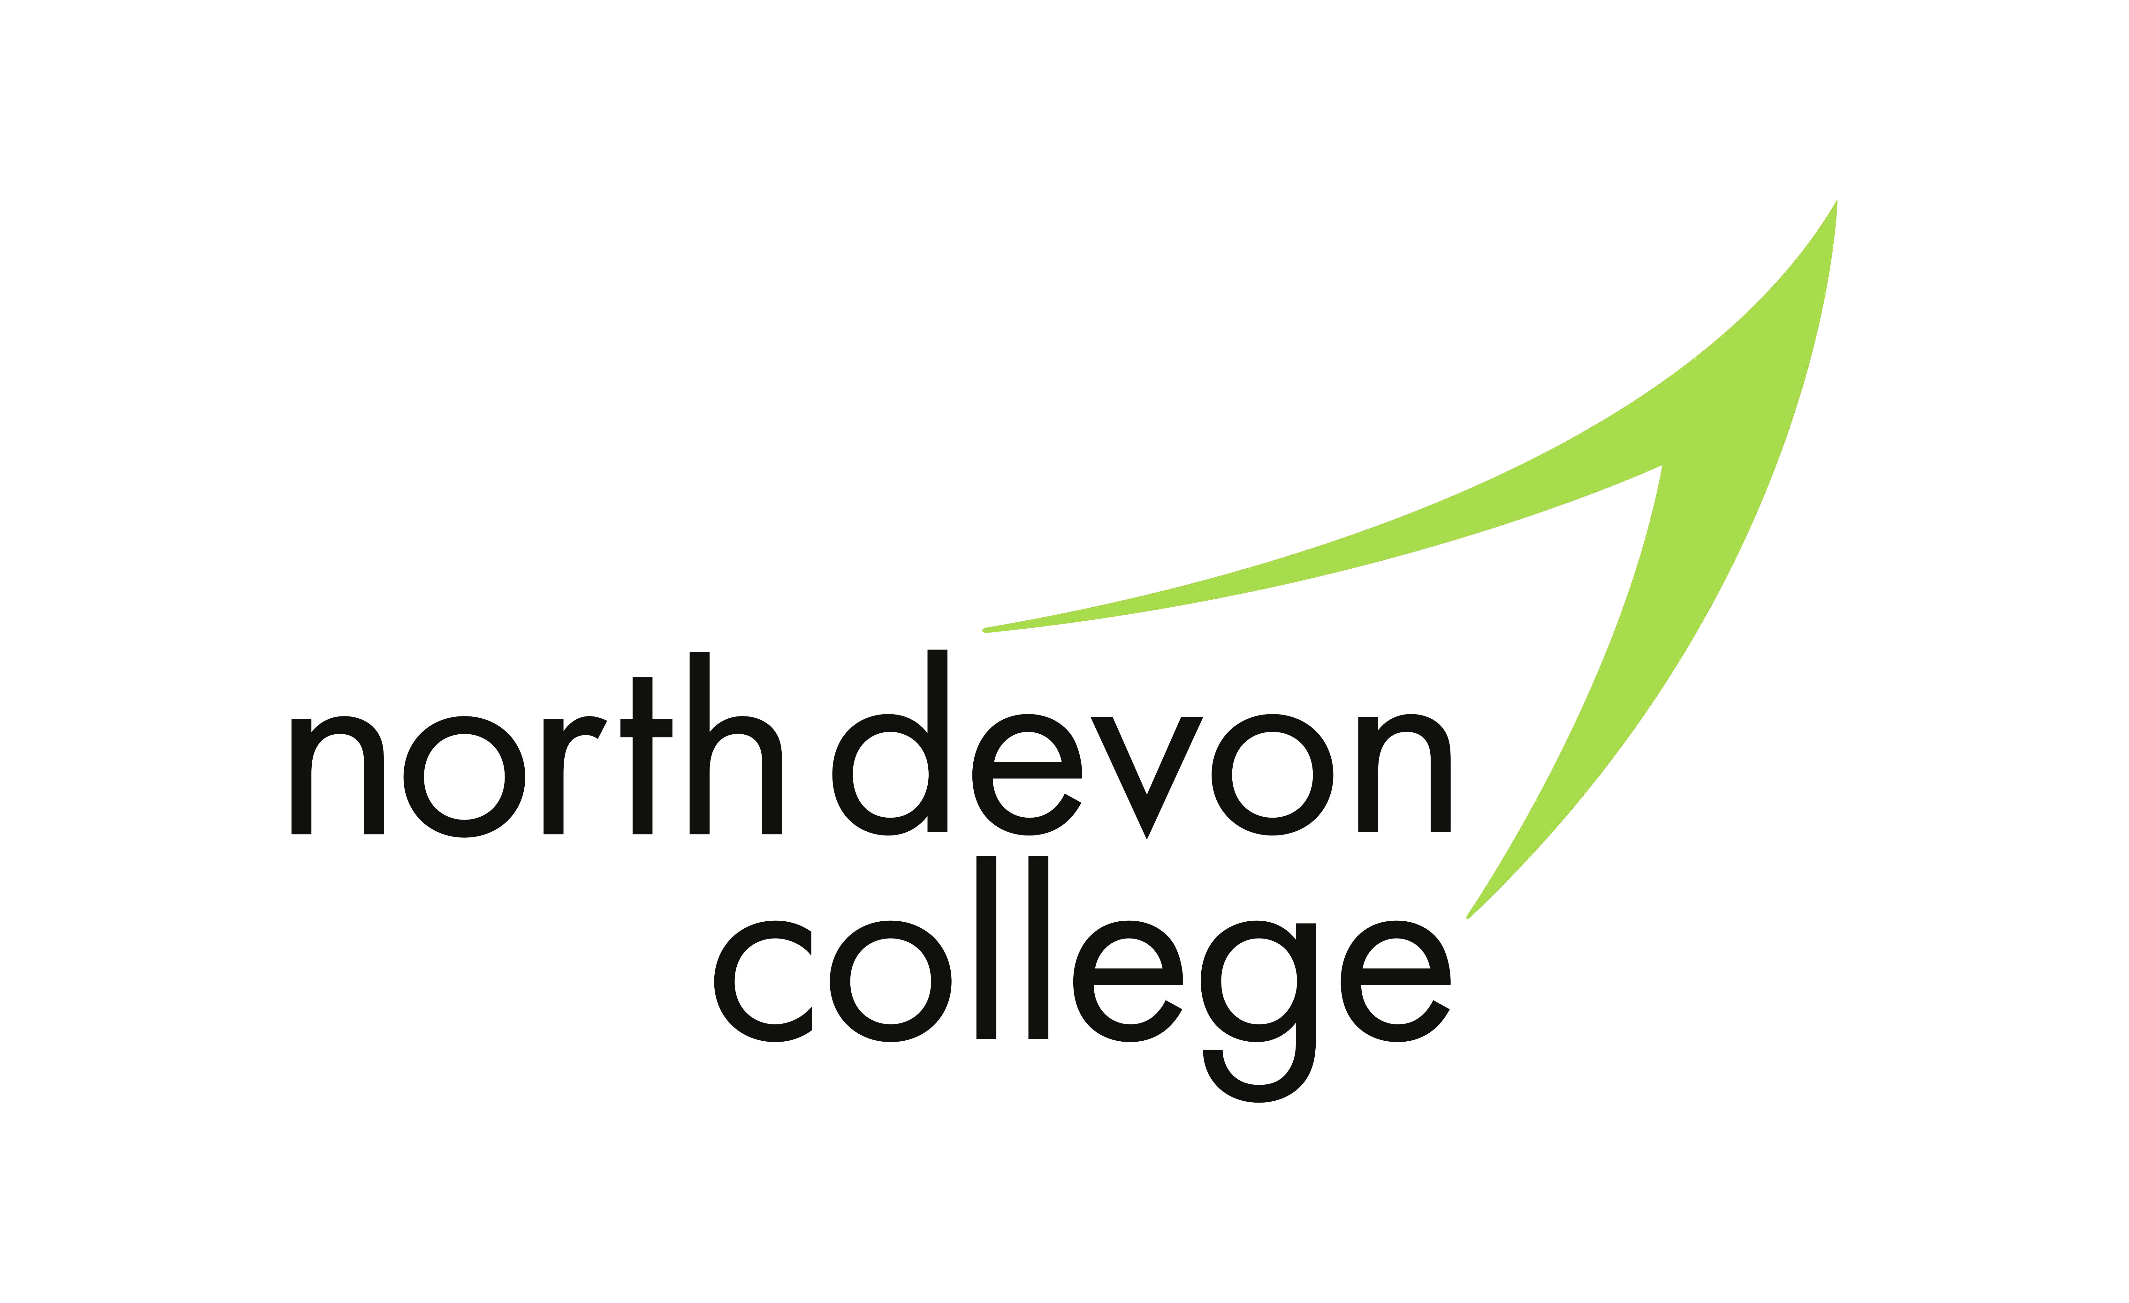

Gents
Cut
Moustache Trim Beard Shape-up Wet Shave
Student
£4.50
£2.00
£3.00
£5.00
Hair Removal
Student
Full Leg
£10.00
Face
Dermalogica Relaxing Facial Rejuvenating Facial
Skin Solution Facial
Student
£15.00
£15.00
£15.00
Colouring & Chemical Services
Student
Regrowth Colour & Ends Refresh
£30.00
Half Head Foils
Full Head Foils Colour Correction
Background Colour/Toner
from
from
£25.00
£30.00
£35.00
£10.00
*WHEN BOOKING A CHEMICAL SERVICE WITH A STUDENT THE CUT AND FINISH IS COMPLIMENTARY.
Makeup | Student
30 min makeup demo (choice of eyes or base) | £10.00
60 min makeup demo (choice of eyes or base) | £20.00
Lash Lift | £15.00

Perm | from | £25.00
Regrowth Colour |  | £25.00

Full Head Colour | from | £30.00
Placement Foils | from | £5.00
T-Section Foils |  | £20.00

Gel Polish | £15.00
Gel Polish Removal | £5.00
Pedicure | £10.00
Deluxe Pedicure | £12.00
NSI Nail Extensions | £12.00
NSI Infills & Rebalance | £10.00

HAIR BEAUTY
Dry Cut
Blow Dry
Shampoo and Set (Short Hair) Hair Up
Nourishing Hair Treatment
£5.00
£5.00
£5.00
£8.00
£5.00
Eyebrow Tint
Eyebrow Shape/Wax
£5.00
£5.00
Nails
Manicure
Deluxe Manicure
Student
£8.00
£10.00
NSI Nail Removal
£10.00
Full Body Massage
Sports Therapy Massage Hot-Stone Therapy Body Wrapping
£15.00
£10.00
£15.00
£15.00

Ladies | Student |  | Eyes | Student |  | Body | Student
Wet Cut | £5.00 |  | Eyelash Tint | £5.00 |  | Indian Head Massage | £8.00

Tanning
St. Tropez Cream or Spray Tan
St. Tropez Body Prep & Spray Tan
Student
£12.00
£16.00

Upper Lip or Chin | £4.00
Underarm | £4.00
Bikini Line | £5.00
Half Leg | £6.00

