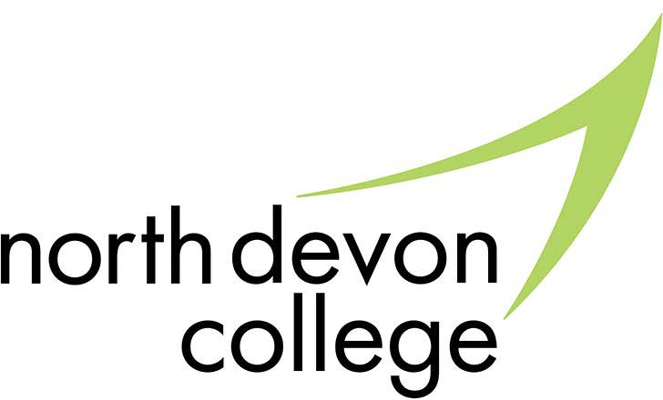



Do learners have to attend college to complete a Study Programme?
No. However, if they do not attend college they must be undertaking one of the following training routes: Full time education; an apprenticeship; full time work with training; a traineeship; home education; official volunteering activity.
Will all learners take part in work experience?
No, this will depend on the learner’s programme of study. Some Level 1 and Level 2 programmes will have work experience built into them but A Levels will not generally need to include work experience.
Can learners repeat their GCSEs?
Yes. Learners who achieved a D in Maths and/ or English will be able to retake their GCSE. Those who achieved a grade E or below will be able to undertake the appropriate Functional Skill course to work towards the required Maths and/or English GCSE.
What happens if a learner gets a job straight after completing their GCSEs? Those employed once they leave school should be receiving training as part of their employment, either in house or at college. Their employer should arrange this.
What are the options for those with complex learning needs?
Those who aren’t able to study an academic programme or vocational qualification
are required to take a programme of work experience and continue to develop their employability, numeracy and literacy skills.

Barnstaple Campus Old Sticklepath Hill Barnstaple
Devon EX31 2BQ 01271 338125
guidancecentre@petroc.ac.uk

Tiverton Campus Bolham Road Tiverton
Devon EX16 6SH
01884 235330
guidancecentretiverton@petroc.ac.uk
www.petroc.ac.uk

The Study Programme

A new approach to lead 16-19 year olds into further education and employment.
THE STUDY PROGRAMME - FAQs


RAISING THE PARTICIPATION AGE

What does this mean for learners?
From September 2013, the Government’s Raising the Participation Age (RPA) policy will come into effect for learners aged 16 – 19 in England.
This means that all 16 year olds in education will be required to continue in education and training until the end of the academic year in which they turn 17. In other words, a further year after they finish their GCSEs.
This will affect all students currently in Year 11.
And, from September 2015, learners will be required to remain in education and training until the end of the academic year in which they turn 18 (two years past GCSEs).
However, raising the participation age does not mean learners have to stay at school.
Learners will be able to choose from any of the following options:

- Full time education (school, college or home education)
- Apprenticeship
- Traineeship
- Part time education, alongside full time employment or volunteering (20+ hours per week)

WHAT ARE THE OPTIONS AT NORTH DEVON COLLEGE?

A wide range of quality courses
As one of the South West’s leading colleges, we pride ourselves on our wide variety of quality courses we offer and our exceptionally caring and supportive environment to allow our students to achieve their full potential.
Our A Levels and Apprenticeships were hailed as ‘outstanding’ in the 2012 Ofsted report and our students continue to break records with their phenomenal results year on year.
We also have a huge range of highly successful vocational courses to choose from, including engineering, personal training and hairdressing and we work with hundreds of employers to deliver bespoke training.
Everything we do is aimed at giving students the best possible learning and life experience, with the highest quality teaching, resources and facilities.
To find out more about the courses on offer
at North Devon College call our Guidance Centre on
01271 338125 (Barnstaple) or 01884 235330
(Tiverton) or visit www.petroc.ac.uk

THE STUDY PROGRAMME

Leading 16 - 19 year olds into further education and employment
To ensure all our learners get the most out of their time at college they will be enrolled on a Study Programme when they start in September.
The Study Programme will consist of between 540-600 learning hours per academic year and will contain either an academic programme or vocational qualification, for example A Levels, Extended National Diploma, Award, Certificate or Diploma.
The hours will be made up of both the qualification and non-qualification activities, such as tutorial sessions and work experience.
The Study Programme will be broken down into the following areas:

- A main qualification or group of qualifications (vocational/academic)
- GCSE Maths and/or English, for those who don’t currently hold a grade C or above
- Academic progress support and tutorial support
- Optional extra activities (e.g. sport, film club or chess club)
- Work experience, where appropriate

