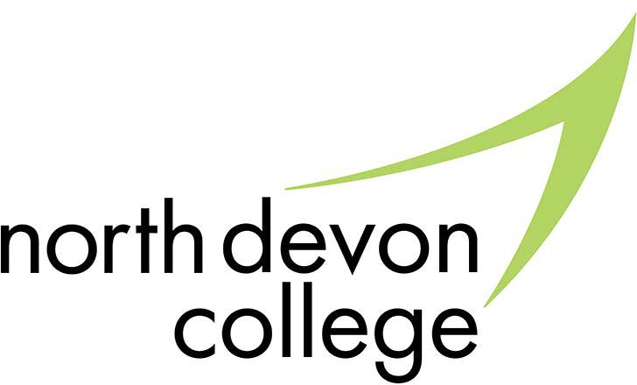

Study Programmes FAQs

The Study Programme is a new approach to lead 16-19 year olds into further education and employment.

Will I need to attend college?
Yes, for a full time North Devon College course you’ll need to attend college but you might not need to if you are undertaking one of the following training routes.
- an apprenticeship
- full time work with training
- a traineeship
- home education
- take part in an official volunteering activity
North Devon College can provide education and training for all of the above options, for example, full A-level programmes, full BTEC programmes and Apprenticeships.

How long must I attend a study programme for?
You are required to stay in education until the end of the academic year in which you turn
18. There are many options to choose from, and it is important that you complete a programme once you start it.

How many hours must I attend college for?
Exact hours at college will depend on your programme of study, either an academic programme or vocational qualification. The Study Programme will require you to attend college between 540 - 600 planned learning hours per academic year and consist of a mixture of qualification and non-qualification (eg tutorial and work experience) hours.

Will I need to do work experience?
This will depend on the programme of study you have undertaken but work experience is an expected and important part of every study programme. All learners will receive support in securing work experience relevent to their career aspirations.

How many hours will I need for work experience?
This will depend on your study programme and your GCSE results. If you are on a study programme and
currently have a maths and English qualification at grade 4 and above, then work experience can be built into your programme. This could be for as little as six hours per week for 36 weeks and can take place in the college’s real work environments.

How will I know my work experience placement is safe?
All work placements will be assessed by the college and the appropriate Health and Safety checks carried out.

Can I repeat my GSCE’s in Maths and English?
Yes, all your studies will be targeted to support the development of employability skills, including Digital Academy. You will be able to identify employability skills you acquire by using ‘badges’ to highlight to employers your successes at North Devon College.

Will my programme help me with work skills?
Part of the study programme will be called non qualification hours. These hours will consist of programmes such as tutorial, study skills, employability skills or even work experience. These programmes will be mandatory as they are also included in your study programme.

What are Badges?
Badges identify key employability skills that employers are looking for in their employees.
At North Devon College we help you to recognise the development of these important skills and collect evidence to use for your personal statements for university or for letters and interviews for jobs.

Can I do an apprenticeship?
Yes, if you are employed and want to come to college to complete the apprentice programme then you can.

What happens if I get a job?
If you are employed once you have left school then you should be receiving 280 training hours per annum and qualification based training as part of your employment, either in your workplace or at a college. Your employer should organise this for you, but you can also contact us direct to discuss training.

What options do I have if I have complex learning needs?
Those students who aren’t able to study an academic programme or a substantial vocational qualification are required to take a programme of work experience and continue to develop their numeracy and literacy skills. This is still limited to 540-600 hours per week and takes place over four days a week.

What is a Traineeship?
A traineeship is a structured support programme to help young people into work and is a pathway of the Study Programme at 16-19. It is also open to 19-24 year olds through Jobcentre Plus. The objective of the Traineeship is to help young people progress to an Apprenticeship or another ‘good job’, i.e. a sustainable position. Through putting work preparation and work experience at the centre of the programme, it is hoped to ensure students receive sufficient in-job support and mentoring so they can retain a job or return to college to complete a Level 3 qualification.

What does a Traineeship involve?
The Traineeship has four key elements:
- Preparation for work - finding and retaining a job
- Work experience - extended where possible
- English and maths - for those not yet at Grade C in Maths and English
- Vocational preparation - this may be appropriate if the traineeship is being designed to link specifically to a sector ie Construction, Engineering, Hair and Beauty etc.
The expected completion time is six months. Research suggests people with Level 2 literacy and numeracy skills are more likely to retain their jobs than those without, hence the importance of this element in the programme.

For more advice and guidance please contact:

Barnstaple Campus

Old Sticklepath Hill, Barnstaple,

Tiverton Campus

Devon, EX31 2BQ Bolham Road, Tiverton,
01271 852422 Devon, EX16 6SH 01884 235330
guidancecentre@petroc.ac.uk guidancecentretiverton@petroc.ac.uk

